Table of content:

- Full Digitized Report (FDR)
  - Digital Maturity Assessment (DMA)
  - Industrial Transformation Readiness (ITR)
  - Digital Process Blueprint
  - Use case Generation
  - Business Case & Phasing Process
- Methodology
  - Evaluation
  - Requirements
  - Research & Analysis
  - Design
  - Testing
  - Implementation

—— Full Digitized Report (FDR) ——

1. Digital Maturity Assessment (DMA)

The Digital Transformation Maturity Survey is designed to assess the digital maturity and readiness of the organization.
- Governance & Leadership
- People (Organizational Design, Talent Capability & Development, Talent Strategy)
- Process (Analysis Method, Data Management, Insight Development, Business Intelligence)
- Strategy & Innovation (Digital Strategy, Investment, Competitive Intelligence)
- Technology (Digital Tools, Data Acquisition, Cyber Security)

Governance & Leadership

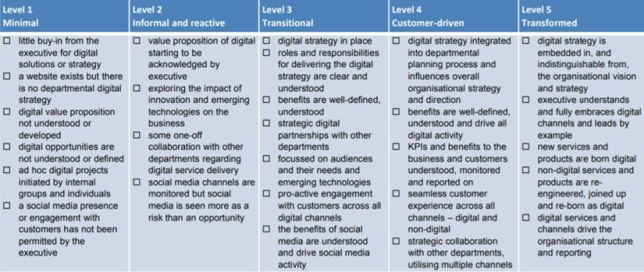

Maturity level: 1 ⬜ 2 ⬜ 3 ⬜ 4 ⬜ 5 ⬜

People

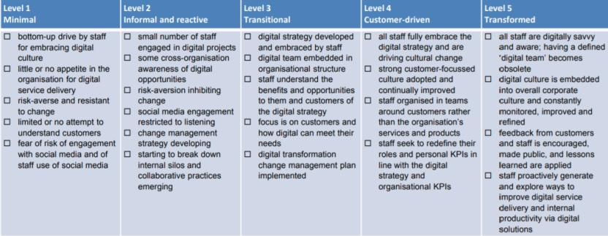

Maturity level: 1 ⬜ 2 ⬜ 3 ⬜ 4 ⬜ 5 ⬜

Process and Capacity

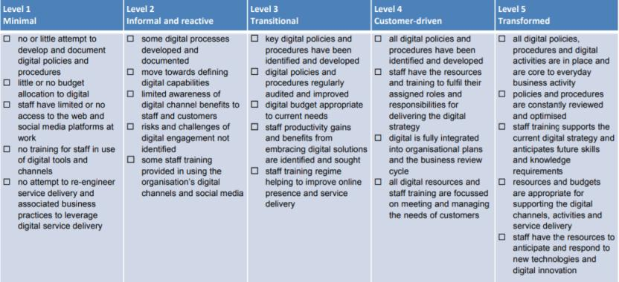

Maturity level: 1 ⬜ 2 ⬜ 3 ⬜ 4 ⬜ 5 ⬜

Strategy & Innovation

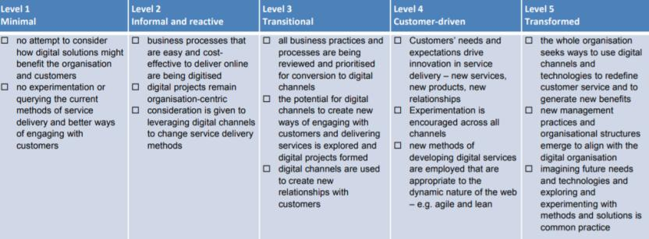

Maturity level: 1 ⬜ 2 ⬜ 3 ⬜ 4 ⬜ 5 ⬜

Technology

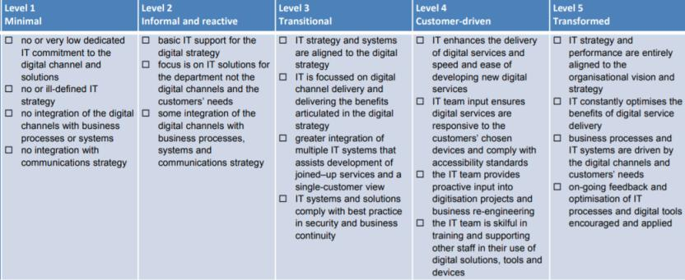

Maturity level: 1 ⬜ 2 ⬜ 3 ⬜ 4 ⬜ 5 ⬜

Calculate the DMA: Total Points / 5

The result calculation will give an estimation of the ability of an organization to respond and take advantage of technological developments.

Questions to ask a company about their digital strategy?

1- How mature is your current capabilities in IT, Culture, Strategy and Governance?
2- What could you gain by digitizing your industrial factory, process or all organization?
3- How is your end-point customer behavior changing and how does my relationship to customers need to change in response?

2. Industrial Transformation Readiness (ITR) Model

Employees:
Employees help companies realize their digital transformation and are the ones most affected by the changes of the digital workplace. Their direct working environment is altered, requiring them to acquire new skills and qualifications. This makes it more and more critical that companies prepare their employees for these changes through appropriate training and continuing education.
Readiness in the dimension of employees is determined by analyzing employees skills in various areas and the company’s efforts to acquire new skill sets.
- Who are the customers?
Identify the customers needs and wants, attain their efforts and analyze how the business retains it's customers.
- How many employees?
Identify the number of employees in the traditional process and will the digital transformation will decrease the number of employees or not.

Strategy and Organization:
Industry 4.0 is about more than just improving existing products or processes through the use of digital technologies – it actually offers the opportunity to develop entirely new business models. For this reason, its implementation is of great strategic importance.

- Plan the scope of the business.
Includes identifying and documenting the project's goals, deliverables, tasks, project members, deadlines, and milestones. Documentation consists of the scope statement, statement of work, and a breakdown of the work structure.
- Who are the suppliers?
Identify the suppliers supply chain and how the overall logistical operations work.
- Who are the competitors?
Identify the competitors of the company and analyze what type of machines and systems are used in the production line.
- Top challenges?
Carefully document the challenges that will be faced through the transformation roadmap.
- Future opportunities?
Write down the opportunities that will be introduced once the transformation is implemented.

Smart Factory:
Successful implementation of Industry 4.0 enables distributed, highly automated production. Unlike in traditional production, smart workpieces will control and monitor the production process and, in the final expansion phase, guide themselves autonomously through production.
This happens in the environment of the smart factory. The smart factory is a production environment in which the production systems and logistics systems largely organize themselves without human intervention. The smart factory relies on cyber-physical systems (CPS), which link the physical and virtual worlds by communicating through an IT infrastructure, the Internet of Things. Industry 4.0 also involves digital modeling through the smart gathering, storage, and processing of data. In this way, the smart factory concept ensures that information is delivered and resources are used more efficiently. This requires the real-time, cross-enterprise collaboration between production systems, information systems, and people. These integrated systems produce huge amounts of data that are processed, analyzed, and integrated into decision-making models.

- Type of digital change?
What is the change the factory is requesting ? Full Digital Transformation or Partial ? If so they must decide in order to create a pilot conversion in the implementation phase.
- Current factory technologies.
What machines the factory is using to do it's operations and compare the performance with current and future machines.

Smart Operations:
One hallmark of Industry 4.0 is the enterprise-wide and cross-enterprise integration of the physical and virtual worlds. The advent of digitization and the plethora of data it has brought to production and logistics have made it possible to introduce what are in some cases entirely new forms and approaches to production planning systems (PPS) and supply chain management (SCM). The technical requirements in production and production planning necessary to realize the self-controlling workpiece are known as smart operations.

Smart Products:
Smart products are a vital component of a unified “smart factory” concept facilitating automated, flexible, efficient production. Physical products are equipped with ICT components (sensors, RFID, communications interface, etc.) to collect data on their environment and their own status. Only when products gather data, know their way through production, and communicate with the higher-level systems can production processes be improved and guided autonomously and in real time. It also becomes possible to monitor and optimize the status of the individual products.

- Market Supply / Demand
Create a market analysis profile that measures the market supply and demand and how it will impact the digitization process.
- What are the products?
What are your client's products ? How are they produced and how the digital transformation will effect the process.

Data Services:
The objective of data-driven services is to align future business models and enhance the benefit to the customer. The after-sales and services business will be based more and more on the evaluation and analysis of collected data and rely on enterprise-wide integration. The physical products themselves must be equipped with physical IT so they can send, receive, or process the information needed for the operational processes. This means they have a physical and digital component, which in turn are the basis for digitized services in the usage phase of the products.

3. Digital Process Blueprint

Industry 4.0 Decision Strategy

The Industry 4.0 Decision Strategy will shape every further step a company takes on the path towards becoming a fully digital enterprise, so it’s important to take the time to clearly define your vision. Evaluate your own digital maturity now and set clear targets for the next five years

Moving from the current to the future desired state will need precise steps and a clear prioritization. Benchmarks in the bottom picture will identify the desired state of any company that wants to adopt digital transformation.

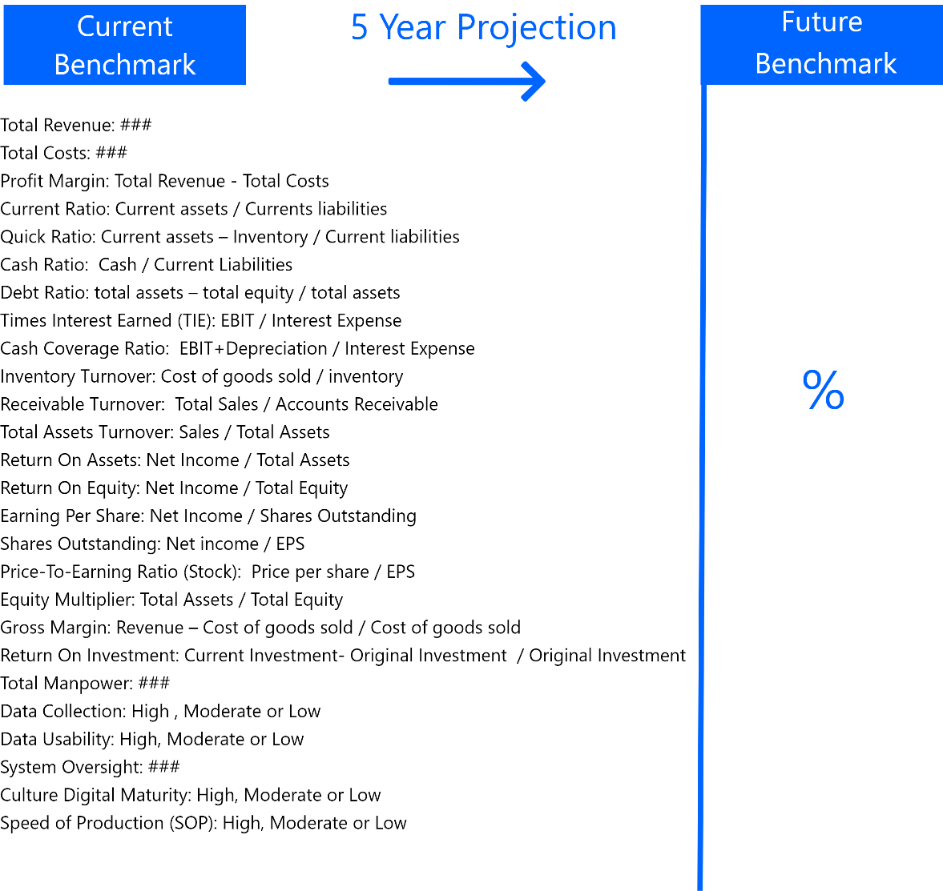

Transformation Class

As an SIDF investigator, You have to profile what the client actually needs?
What type of digital transformation is he seeking?
These are the 7 Classifications of Digital Transformation, as SIDF will mostly deal with companies who want to adopt the third classification (Vertical Integration Transformation) Because it contains the automation use cases, digital factory, use of data and analytics and asset management software

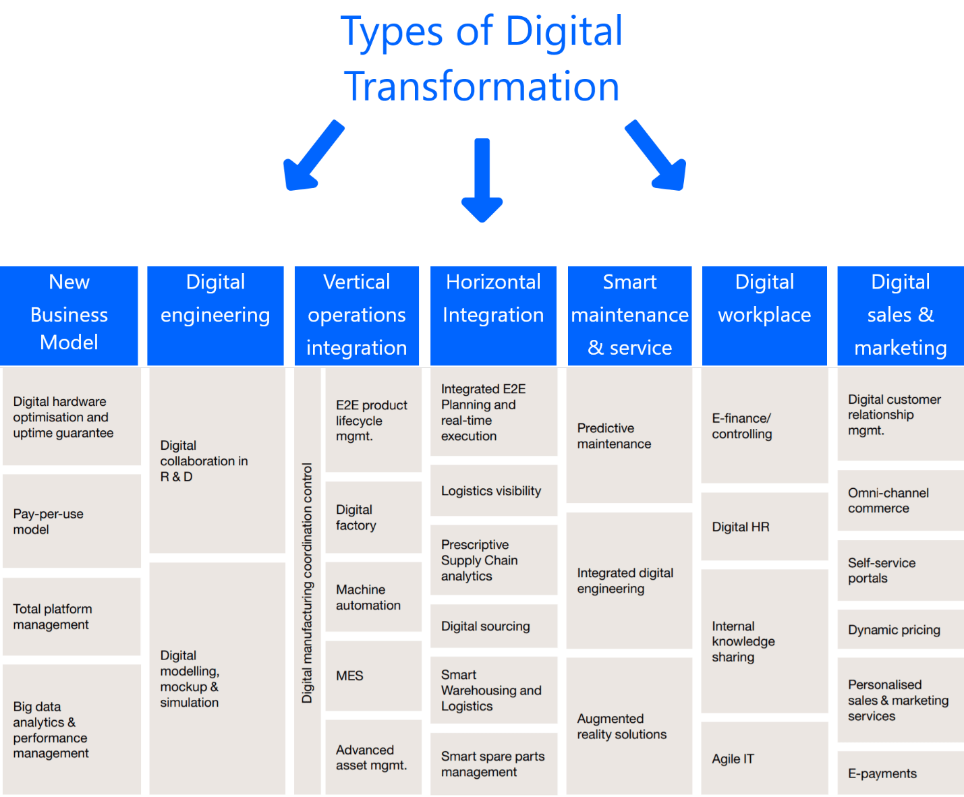

Capabilities Analysis

Building on the lessons learned in Projects type selection, map out in detail the enterprise architecture and what capabilities they need. Include how enablers for Industry 4.0, like an agile IT infrastructure, can fundamentally improve all of the business processes. The most successful approaches look at which capabilities are needed to enable new digital business models or internal digitization. To implement a new capability, you’ll need to consider four strategic dimensions: organization, people, process and technology. Which is written in the DMA in the first section of the page.

Data Analytics Integration

(Client Assessment) Data is the fuel of any transformational project, consider identifying and gathering the right data, deploying it for the right purposes and effectively analyzing it will be critical to make the right Industry 4.0 decisions. Defining and developing an effective data analytics strategy will require a focus on:
• Predictive analytics and forecasting
• Prescriptive analytics
• Business-driven decision-making
• Automated feedback to the organization

Enterprise Transformation

Digital Culture is key to any organizational change, creating an accepting environment in a facility or a process will help the enterprise to accelerate its transformation as much as possible, Invest in people.

Ecosystem Approach

In this final sub-phase, we must understand, model and simulate the factory before and after digital implementation.

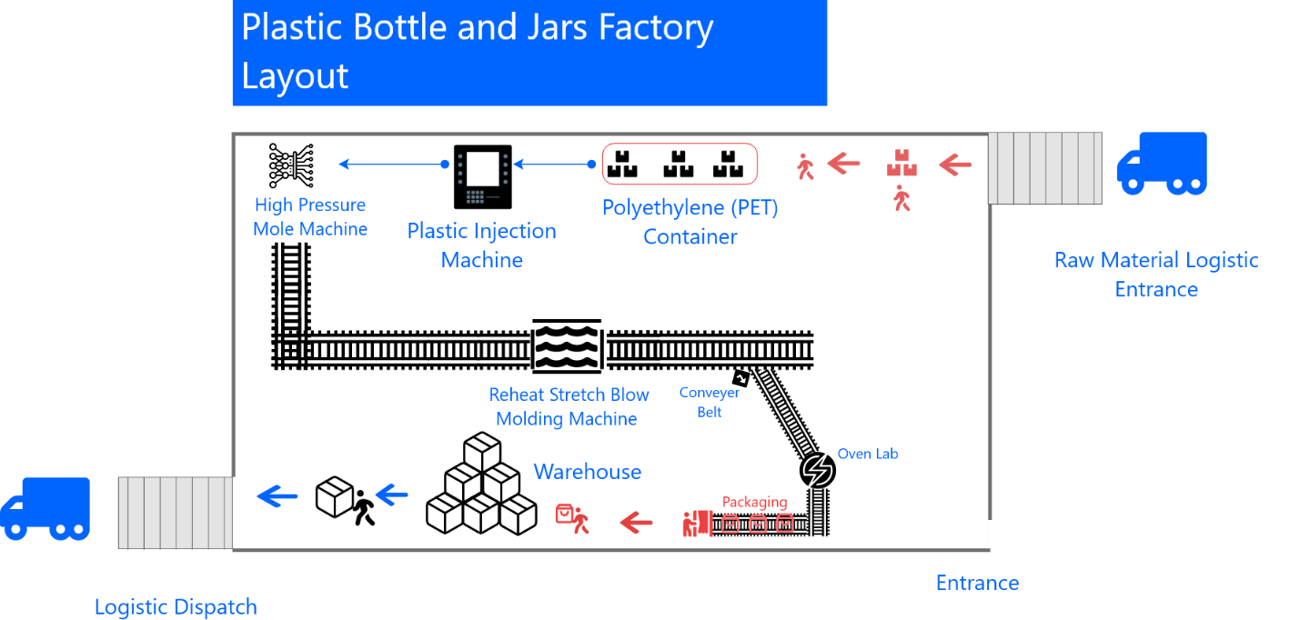

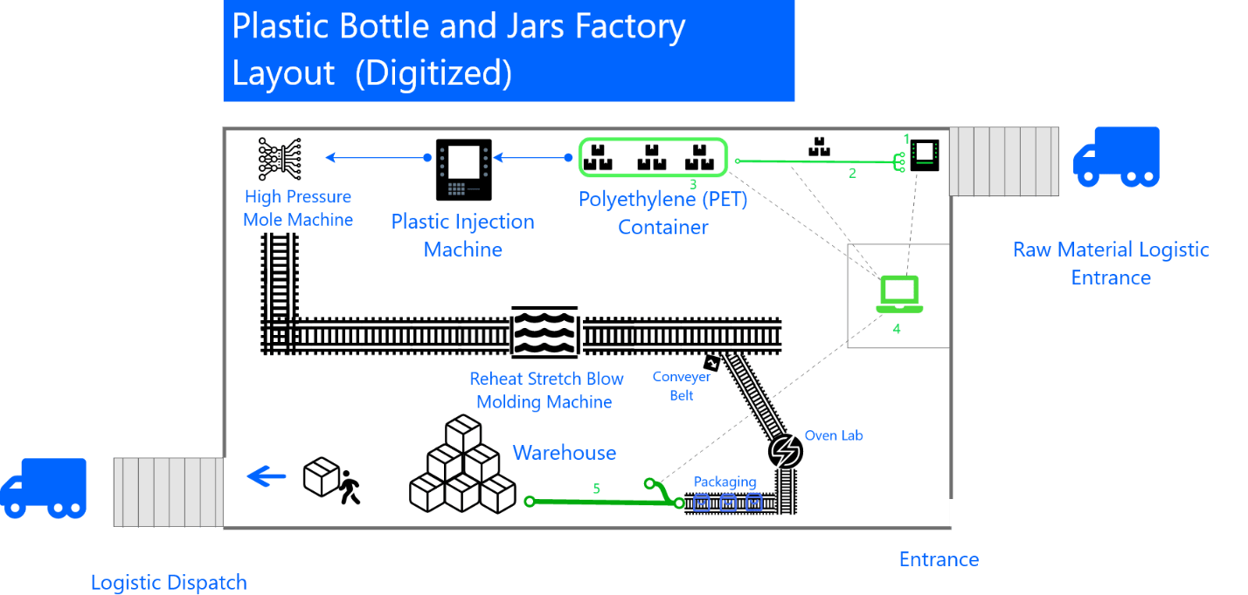

Usecases:

1- Counting and Directing machine: Count Raw Packages, Process Types, Direct Packages to containers.
2- Smart Conveyor: Transporting Raw material to designated location.
3- Smart Material Container: Enable real time insight on Raw materials.
4- UNIVERSAL MACHINE TOOL INTERFACE SYSTEM (UMATI): An open standard system for connecting machine tools and peripherals in IT ecosystems and deliver insights on the production process.
5- Smart Conveyor: Deliver specific sized bottles and jars to designated location in the warehouse.

4. Use Case Generation

Generate a Use Case for the factory.
- A brief description of the use case.
- One or more user stories describing how the use case would be implemented.
- Key requirements of the use case.
- Metrics to measure compliance with the use case, its effectiveness, and the efficiency with which it is being executed.
- Description of the factory resources that would be expected to interact with the use case.
- The knowledge, skills & abilities they would require to be effective and the steps recommended to enable them.
- The benefits that the use case is expected to provide to the factory.
- A brief description of the use case.
- Technical dependencies / prerequisites that must be in place before the use case can be enabled.
- An assessment of the value of the use case as well as the complexity of implementation.
- Phases are assigned by SIDF officers (TBD)

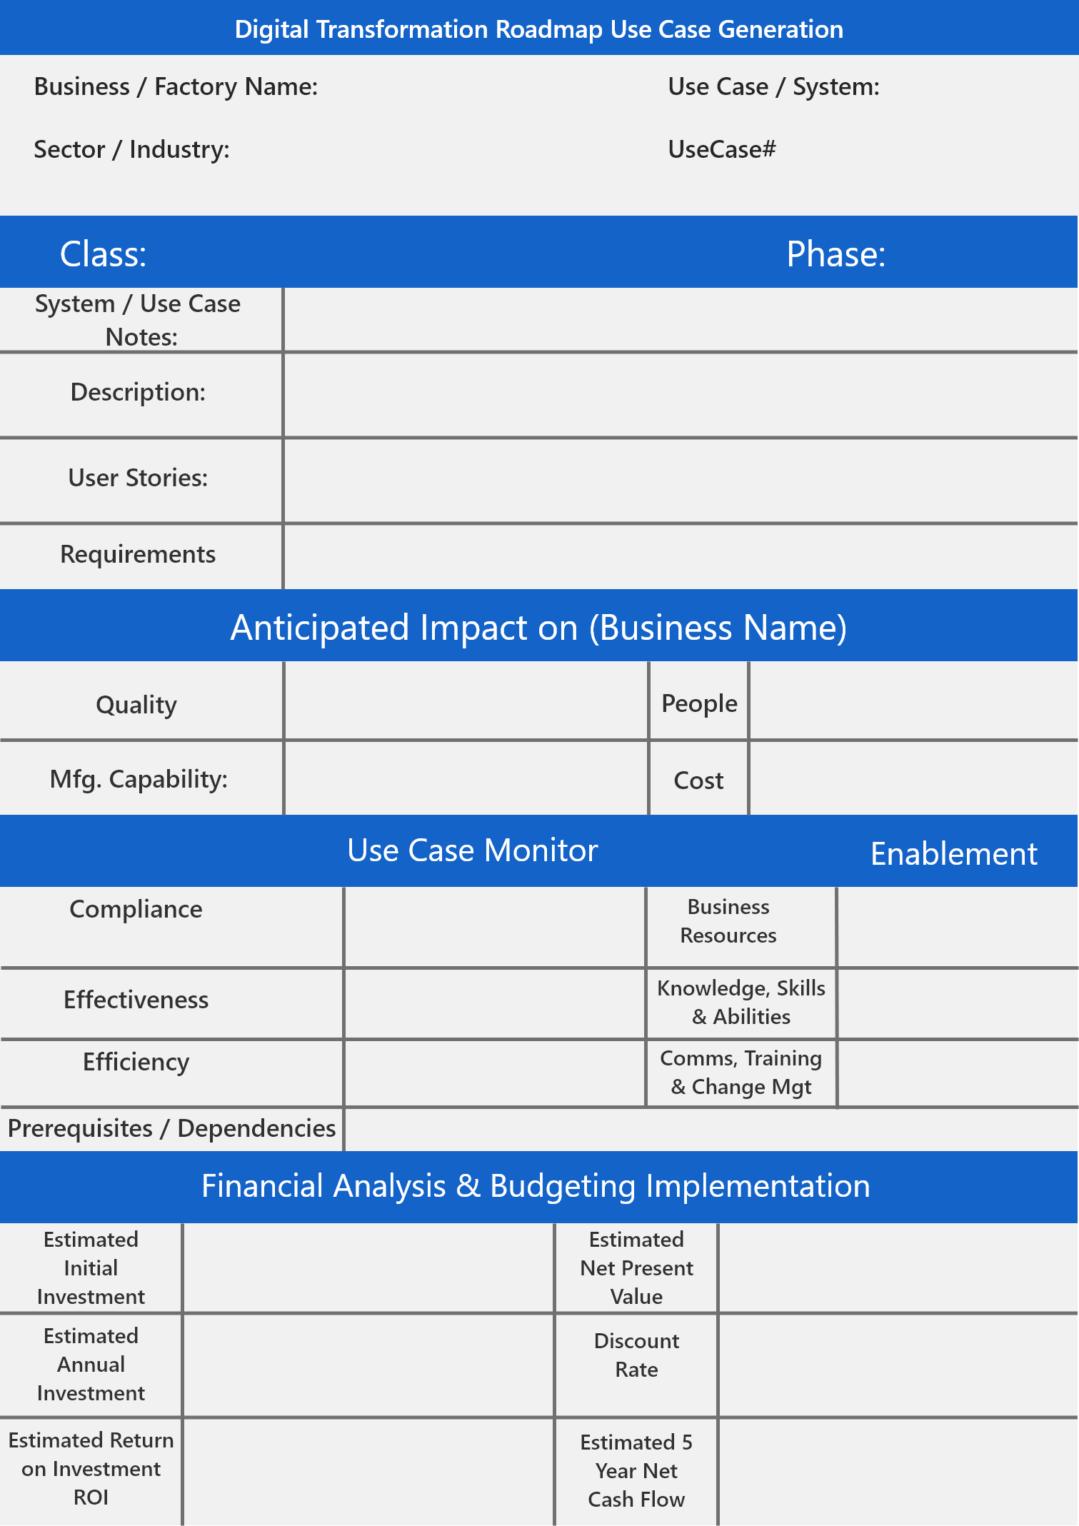

5. Business Case & Phasing Process

Develop a Business Case for the factory.

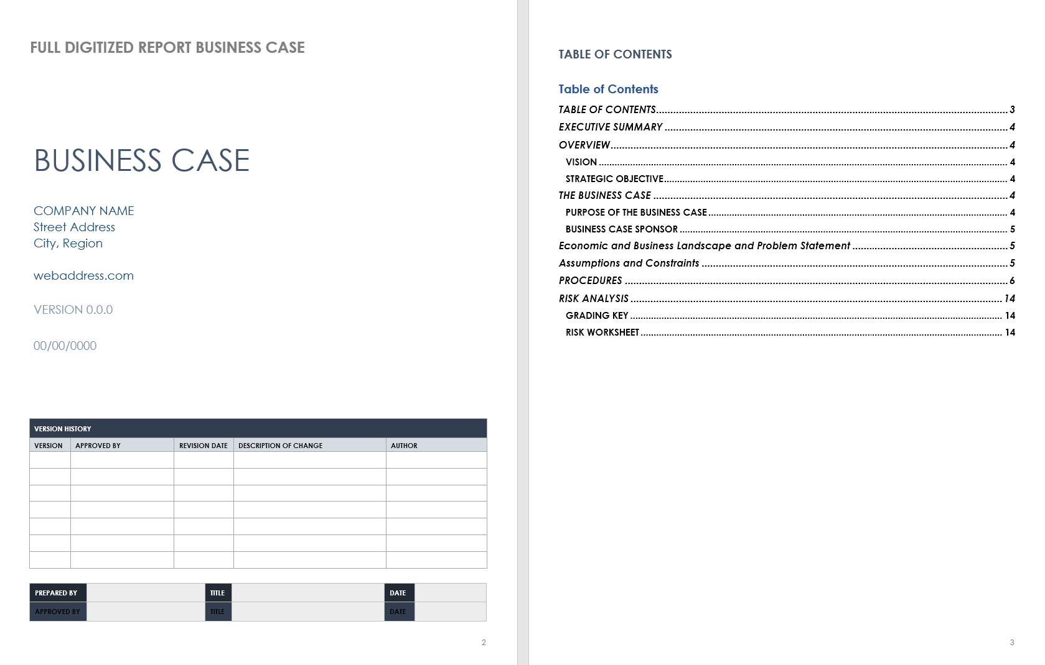

—— Methodology ——

• Evaluation

— Business / Factory Scope

- Plan the scope of the business.
Includes identifying and documenting the project's goals, deliverables, tasks, project members, deadlines, and milestones. Documentation consists of the scope statement, statement of work, and a breakdown of the work structure.
- Who are the customers?
Identify the customers needs and wants, attain their efforts and analyze how the business retains it's customers.
- Who are the suppliers?
Identify the suppliers supply chain and how the overall logistical operations work.
- Who are the competitors?
Identify the competitors of the company and analyze what type of machines and systems are used in the production line.
- Market Supply / Demand
Create a market analysis profile that measures the market supply and demand and how it will impact the digitization process.
- What are the products?
What are your client's products ? How are they produced and how the digital transformation will effect the process.
- How many employees?
Identify the number of employees in the traditional process and will the digital transformation will decrease the number of employees or not.
- Top challenges?
Carefully document the challenges that will be faced through the transformation roadmap.
- Future opportunities?
Write down the opportunities that will be introduced once the transformation is implemented.
- Type of digital change?
What is the change the factory is requesting? Full Digital Transformation or Partial ? If so they must decide in order to create a pilot conversion in the implementation phase.
- Current factory technologies.
What machines the factory is using to do it's operations and compare the performance with current and future machines.

• Requirements

— Environmental Analysis

Create a work plan environment that study and promotes an open mentality oriented towards learning, change and experimentation.

- Warehousing / Logistics
Understand the Warehousing Environment and Process, this includes packaging, refining and deployment of products. Logistics operations and their role in the transformation process.
- Facility Expansions
Facility / Factory expansions should reviewed for potential use in the future, This means how the factory will be able to integrate it's systems if an expansion occurs.
- Manpower Understanding
Create a profile of the level of mentality a factory employee has and develop a work-profile of how the manpower will operate when the digital transformation is implemented.
- Capital Challenges
Identify the funding procedure and prepare an IT Evaluation and costing for industry 4.0 systems and automation machines from affiliated vendors and partners.
- Ecosystem Understanding (BP)
Develop a workflow or a business process diagram that will tackle each issue and reveal how the "new production life cycle" will operate in the factory
- Capital Training & Awareness
Create workshops and meetings with the factory staff and manpower to enable them to understand the new transformation implementation.
- Systems and Technologies
Documentation on the digital transformation systems, machines and services that will be implemented.

— Talent Acquisition

Recruit and manage talent, prioritizing multidisciplinary teams and the capacity to turn data into a strong asset.

- Create a profile for special talents needed
Acquire capital specialized in IoT, Data Science, DL/ML and Machine-to-Machine Communications.
- Consultants integration
Make use of consultants in the field of I4 and integrate them in the process.

• Research & Analysis

— Vendor / Provider Observation

Select a team of providers with tested technologies to start growing the optimal network of partners.

- Vendor Observation
After you have gathered the requirements and the business scope, I'ts time to search for the optimal vendor that can effectively provide the machines, systems and services, and reviewing past implementations.
- Vendor Selection
After observing the market for the right vendor, we send a request to that vendor. (Following SIDF Policies and Rules)

• Design

— Ecosystem Prototyping

Adopt an ecosystem perspective and develop a prototype that simulate the digitalized process abilities.

- Simulate the digitalization process
Create a simulation of how the digital process will operate in the production line
- Quality Assurance and Control
Assemble a QA Team to evaluate the new implementation performance and useability within the design phase.
- System Configuration
Configure the new system design behavior to the needs of the client.
- Digital Ecosystem Modeling
Create a model of the system process that includes: pipelines, machines, sensors, data flow and system protocols for emergency situations.

• Testing

— Pilot Conversion

Start with pilot projects, validate results and systemize the learning mechanisms.

- Test implementation of a digitalized process
Create a trial-and-error procedure with the new implementation and evaluate the results.
- Parallel Testing and Improvement
Align the testing with the improvements and upgrades needed for the new implementation.
- Feedback Documentation
System Performance, throughput of data, scalability of machines must be documented for the final implementation phase.

• Implementation

— Connect
- Operational Efficiency
- Staff Productivity
- Connected Ecosystem

— Collect
- Enable Insights
- Data Lakes

— Control
- Business Innovation
- Data Monetization

— Change
- Business Transformation
- New Business Models

